**About Us**

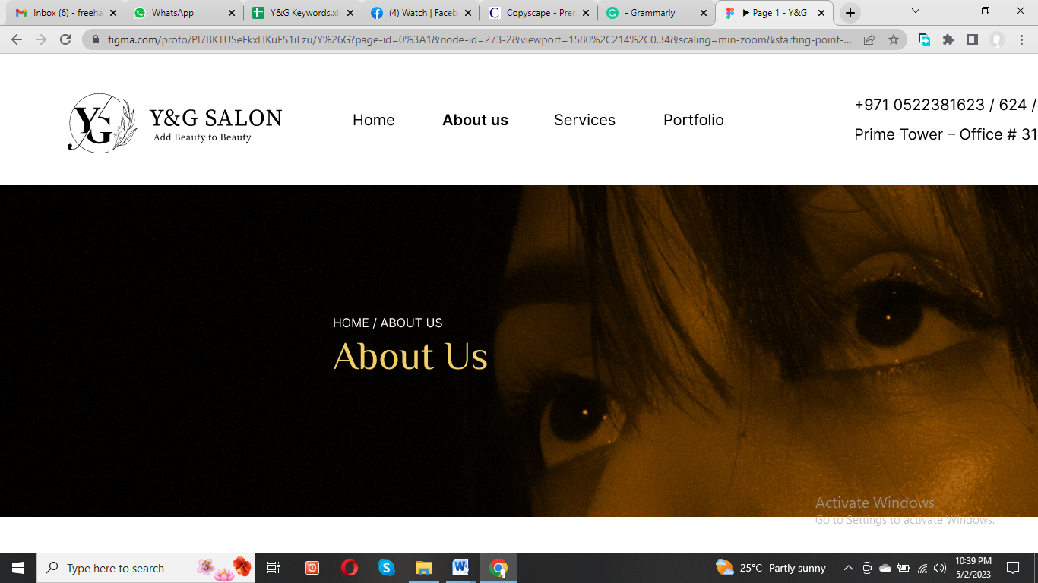

Since our establishment, Y&G Salon has been a shining star in the beauty industry in the UAE. We take pride in our diverse and passionate team of experts who are always ready to assist you in achieving your beauty goals. Our team ensures our clients' happiness with our beauty services, makeup, and other offerings.



Don't hesitate to contact us to schedule an appointment and experience the Y&G Salon difference. Let us make your experience with us a memorable one!

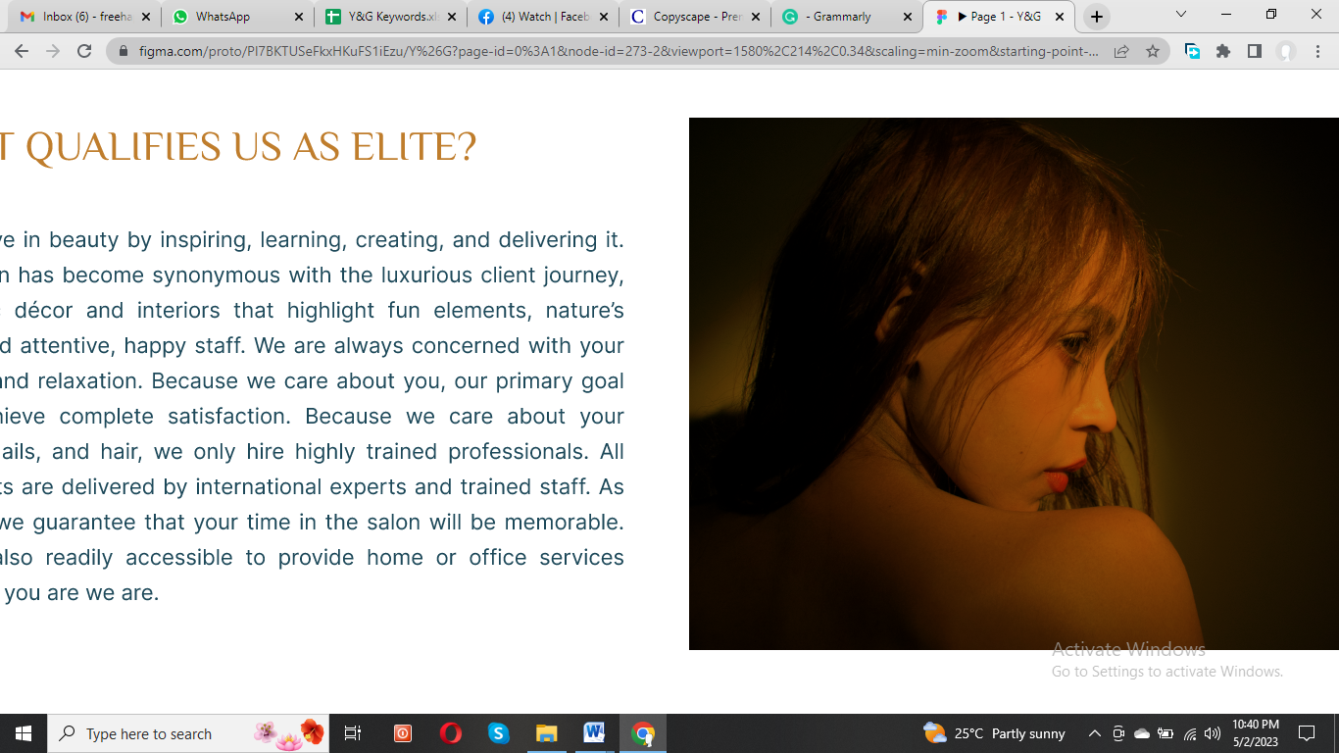

**How We Make Beauty Experience Elite?**

We are passionate about creating beauty and delivering it to our clients. Our luxurious salon offers a unique client experience with stylish decor, natural elements, and friendly staff. We prioritize your comfort and relaxation, ensuring complete satisfaction with our service. Our highly trained professionals specialize in hair, nails, and beauty treatments, ensuring you receive the highest quality services.

All treatments are performed by international experts, ensuring your time in our salon is truly memorable. We even offer home and office services for your convenience. Choose Y&G Salon for an unforgettable beauty experience.

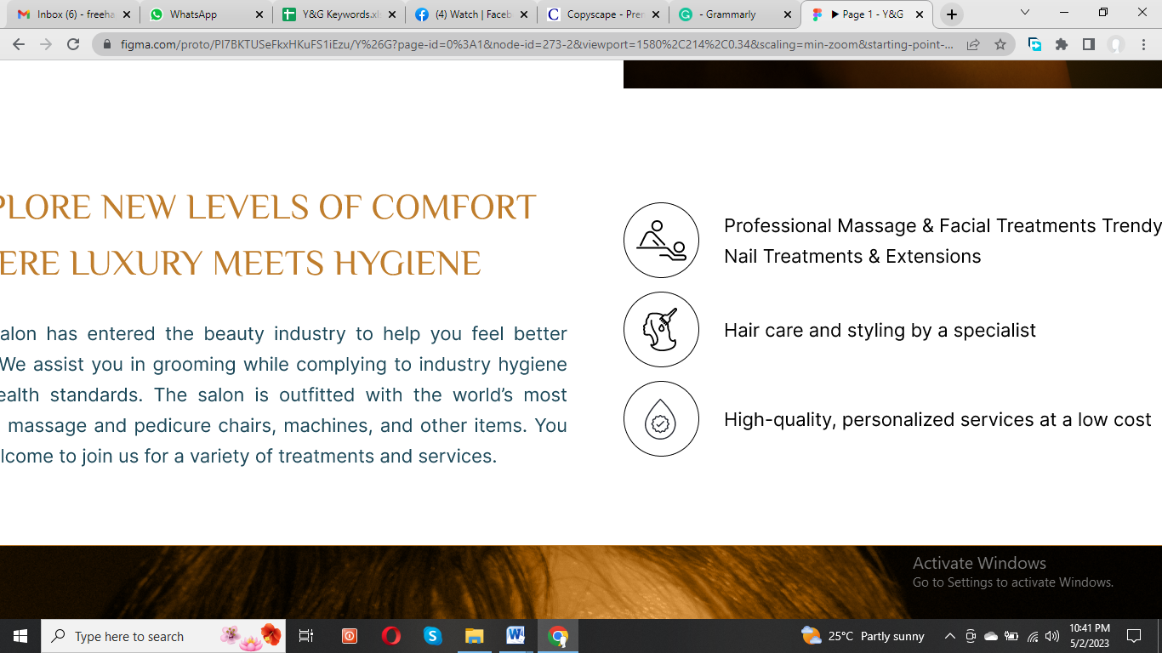

**Luxury and Hygiene Combined: Discover Unprecedented Levels of Comfort**

Y&G Salon is committed to providing you with the best possible beauty experience. Our team of experts ensures that all services and treatments are performed in a safe and hygienic environment. We offer a wide range of services, including professional massage and facial treatments, trendy nail treatments and extensions, and high-quality hair care and styling by our specialists. You can trust us to provide personalized services of exceptional quality at an affordable price.

* Professional Massage & Facial Treatments Trendy Nail Treatments & Extensions
* Hair care and styling by a specialist
* High-quality, personalized services at a low cost

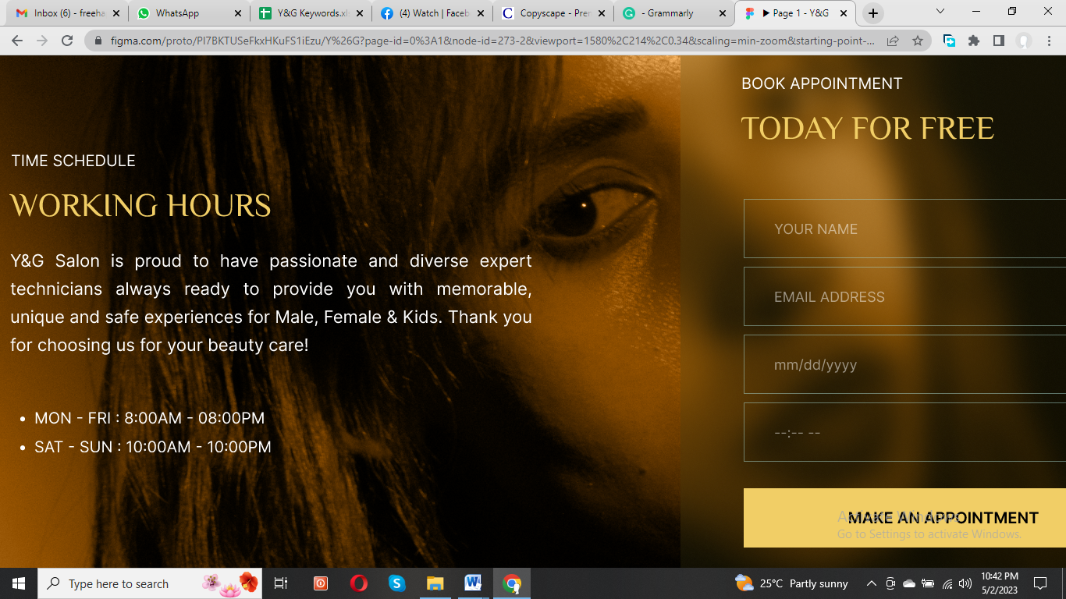

**Time Schedule**

We take pride in our diverse and passionate expert staff, always ready to offer grooming services for kids, females, and males. Our working hours are convenient for everyone, from 8:00 am to 08:00 pm (Mon-Fri) and 10:00 am to 10:00 pm (Sat-Sun).

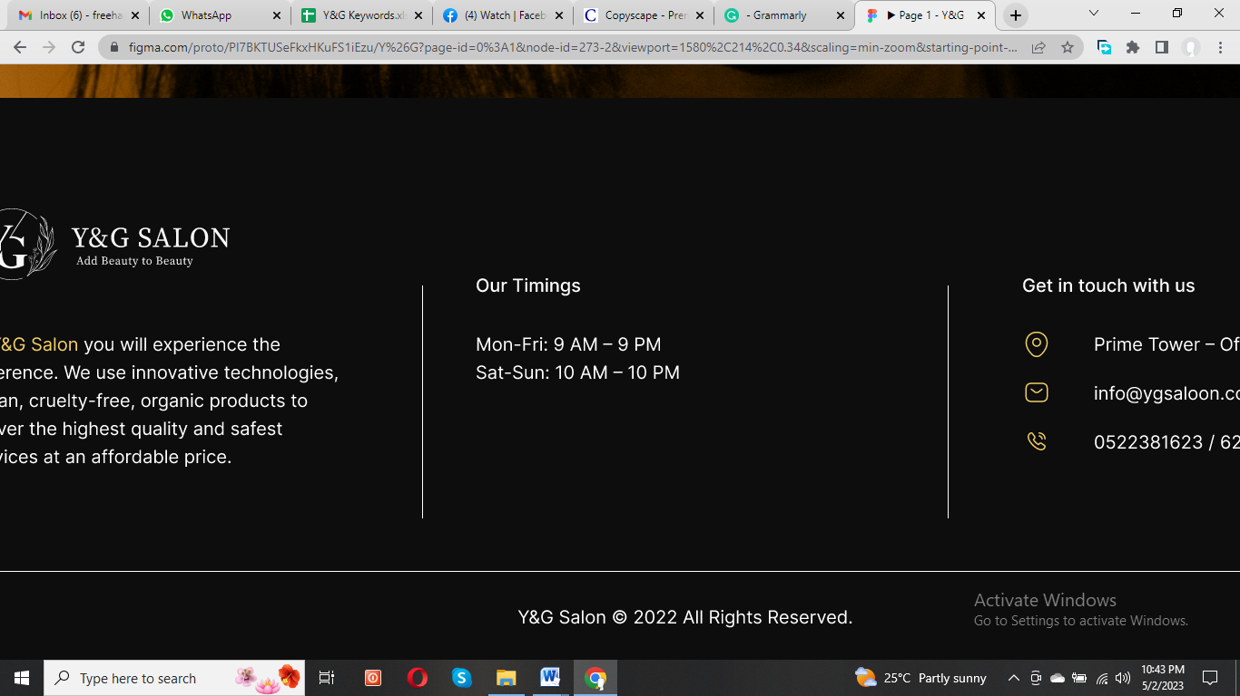

We prioritize hygiene and safety by following all SOPs and regularly disinfecting high-traffic areas to control the spread of diseases. Our use of natural, cruelty-free, vegan, and organic products ensures your health and wellness. Come experience the Y&G Salon difference today!